The charts are not showing unless in “maximized” mode.

Here’s what it looks like when maximized.
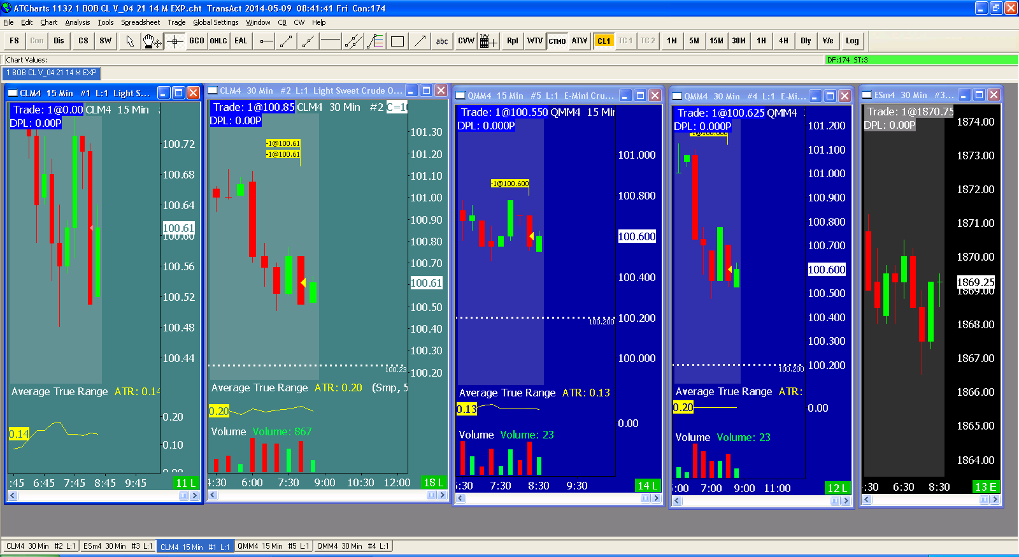

Here’s what it looks like when have chosen reduced size (not “Minimized”)

As you see there are no charts showing.

