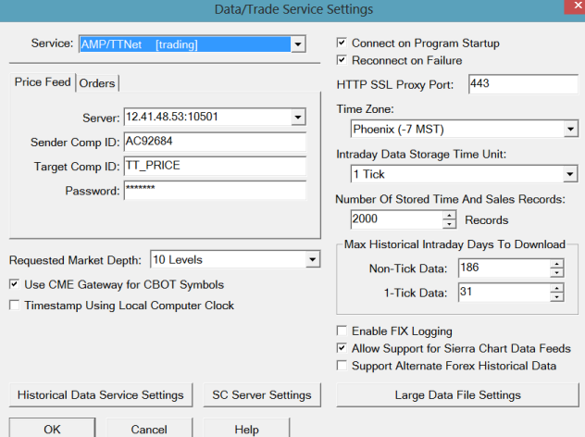

-----------------------------------
Sierra Chart: Data feed disconnected. Will reconnect. | 2014-03-21 13:13:06
Using username 0 | 2014-03-21 13:13:08
SC Exchange Data: Connecting to the server scdf1.sierracharts.com. Port 443 | 2014-03-21 13:13:08
Resolved address ds6.sierracharts.com to IP 8.18.161.131 | 2014-03-21 13:13:08
The network socket is connected. | 2014-03-21 13:13:08
SC Exchange Data: Connected to server. | 2014-03-21 13:13:08
SC Exchange Data: Sending logon request message. | 2014-03-21 13:13:08
Sierra Chart Server Info - Server Name: SC Real-Time Server. Server Version: . Provider Name: Sierra Chart. | 2014-03-21 13:13:08
Sierra Chart - Server protocol version: 3. Client protocol version: 3. There is a protocol match. | 2014-03-21 13:13:08
Sierra Chart - Logon error from server : Limited to one connection per username for the requested data source. | 2014-03-21 13:13:08
Socket has been shutdown and closed. | 2014-03-21 13:13:08
Sierra Chart: Disconnected from the server. | 2014-03-21 13:13:08
Sierra Chart: Data feed disconnected. Will reconnect. | 2014-03-21 13:13:08
Using username 0 | 2014-03-21 13:13:10
SC Exchange Data: Connecting to the server scdf2.sierracharts.com. Port 443 | 2014-03-21 13:13:10
Resolved address ds7.sierracharts.com to IP 8.18.161.133 | 2014-03-21 13:13:10
The network socket is connected. | 2014-03-21 13:13:10
SC Exchange Data: Connected to server. | 2014-03-21 13:13:10
SC Exchange Data: Sending logon request message. | 2014-03-21 13:13:10
Sierra Chart Server Info - Server Name: SC Real-Time Server. Server Version: . Provider Name: Sierra Chart. | 2014-03-21 13:13:10
Sierra Chart - Server protocol version: 3. Client protocol version: 3. There is a protocol match. | 2014-03-21 13:13:10
Sierra Chart - Logon error from server : Limited to one connection per username for the requested data source. | 2014-03-21 13:13:10
Socket has been shutdown and closed. | 2014-03-21 13:13:10
Sierra Chart: Disconnected from the server. | 2014-03-21 13:13:10
Sierra Chart: Data feed disconnected. Will reconnect. | 2014-03-21 13:13:10
Using username 0 | 2014-03-21 13:13:12
SC Exchange Data: Connecting to the server scdf1.sierracharts.com. Port 443 | 2014-03-21 13:13:12
Resolved address ds6.sierracharts.com to IP 8.18.161.131 | 2014-03-21 13:13:12
The network socket is connected. | 2014-03-21 13:13:12
SC Exchange Data: Connected to server. | 2014-03-21 13:13:12
SC Exchange Data: Sending logon request message. | 2014-03-21 13:13:12
Sierra Chart Server Info - Server Name: SC Real-Time Server. Server Version: . Provider Name: Sierra Chart. | 2014-03-21 13:13:12
Sierra Chart - Server protocol version: 3. Client protocol version: 3. There is a protocol match. | 2014-03-21 13:13:12
Sierra Chart - Logon error from server : Limited to one connection per username for the requested data source. | 2014-03-21 13:13:12
Socket has been shutdown and closed. | 2014-03-21 13:13:12
Sierra Chart: Disconnected from the server. | 2014-03-21 13:13:12
Sierra Chart: Data feed disconnected. Will reconnect. | 2014-03-21 13:13:12
Using username 0 | 2014-03-21 13:13:14
SC Exchange Data: Connecting to the server scdf2.sierracharts.com. Port 443 | 2014-03-21 13:13:14
Resolved address ds7.sierracharts.com to IP 8.18.161.133 | 2014-03-21 13:13:14
The network socket is connected. | 2014-03-21 13:13:15
SC Exchange Data: Connected to server. | 2014-03-21 13:13:15
SC Exchange Data: Sending logon request message. | 2014-03-21 13:13:15
Sierra Chart Server Info - Server Name: SC Real-Time Server. Server Version: . Provider Name: Sierra Chart. | 2014-03-21 13:13:15
Sierra Chart - Server protocol version: 3. Client protocol version: 3. There is a protocol match. | 2014-03-21 13:13:15
Sierra Chart - Logon error from server : Limited to one connection per username for the requested data source. | 2014-03-21 13:13:15
Socket has been shutdown and closed. | 2014-03-21 13:13:15
Sierra Chart: Disconnected from the server. | 2014-03-21 13:13:15
Sierra Chart: Data feed disconnected. Will reconnect. | 2014-03-21 13:13:15

