Screenshot for today showing.
- box naming which zone of the current price
- box showing % of gap remaining (market is closed at this writing so it shows N/A)
- lines for cash close of zones…1788.25 high/green, 1777.75 blue for close, 1765.75 white prior open, 1764.75 prior low
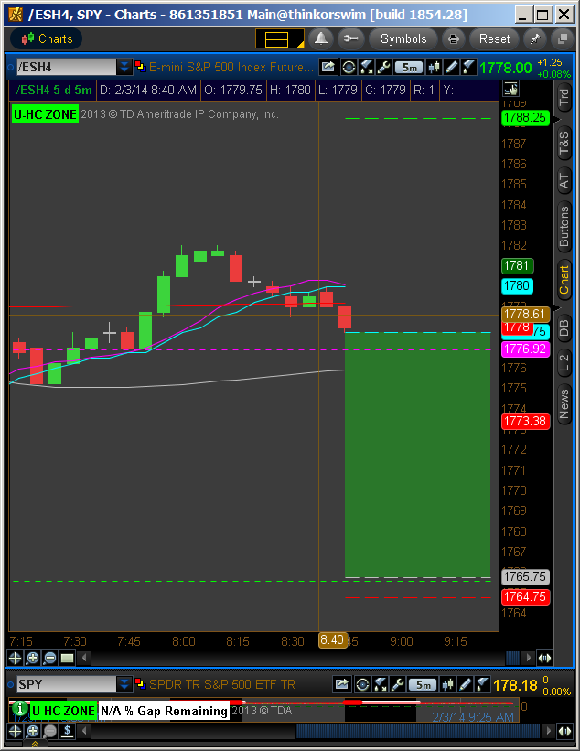
This next screenshot is for a prior day so you can see how it changes as day progresses…
- Blue area shows gap as it filled
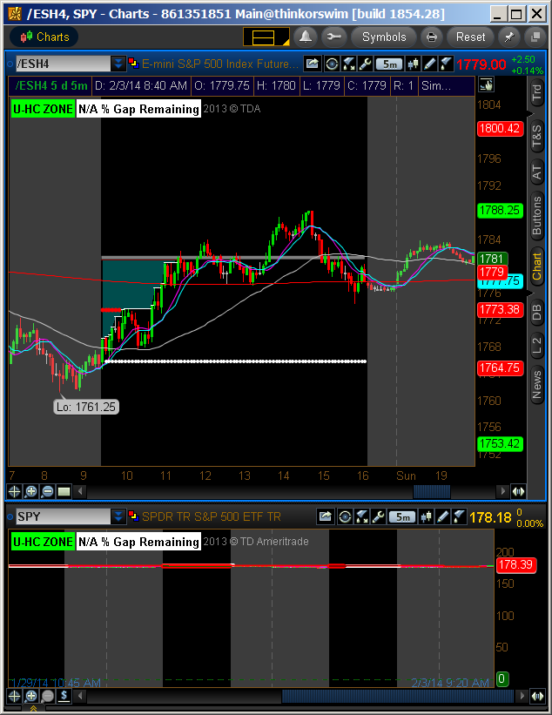

What is missing from this are the two lines showing the high and low of the first hour. They will show on today’s chart at 10:30 Eastern time

What is the way I can add these “indicators” to my Sierra Charts.

