171120 Desired uni-Renko vs SC AT1614 4-2-6 universal renko bars

The following snip is of the desired uni-Renko chart (left) and the SC AT1614 4-2-6 universal renko chart (right).
Note how well all the bars (bodies and wicks) match with one exception at the top of the long bull run (circled). Whatever the code is for the AT1614 universal renko with setting 4-2-6 is, it is very close to what is desired. I still have not found any renko settings in the new version, AT1647, that match as closely.

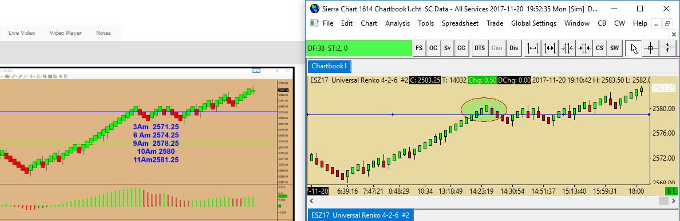

Below is a zoom in on the top of the bull run. Not sure why the charts diverged at the top of the run, but they converged again 3 bars later. On the desired chart, the topping green bar body high at the top of the run would never be greater than the wick or body of a following red bar because in order for the next bar to form following the green topping bar, a price 1 tick higher than the body high of the green topping bar would have to occur, and this price would show up as a wick that is higher than the green topping bar body on a following red bar (as shown on the desired chart).

